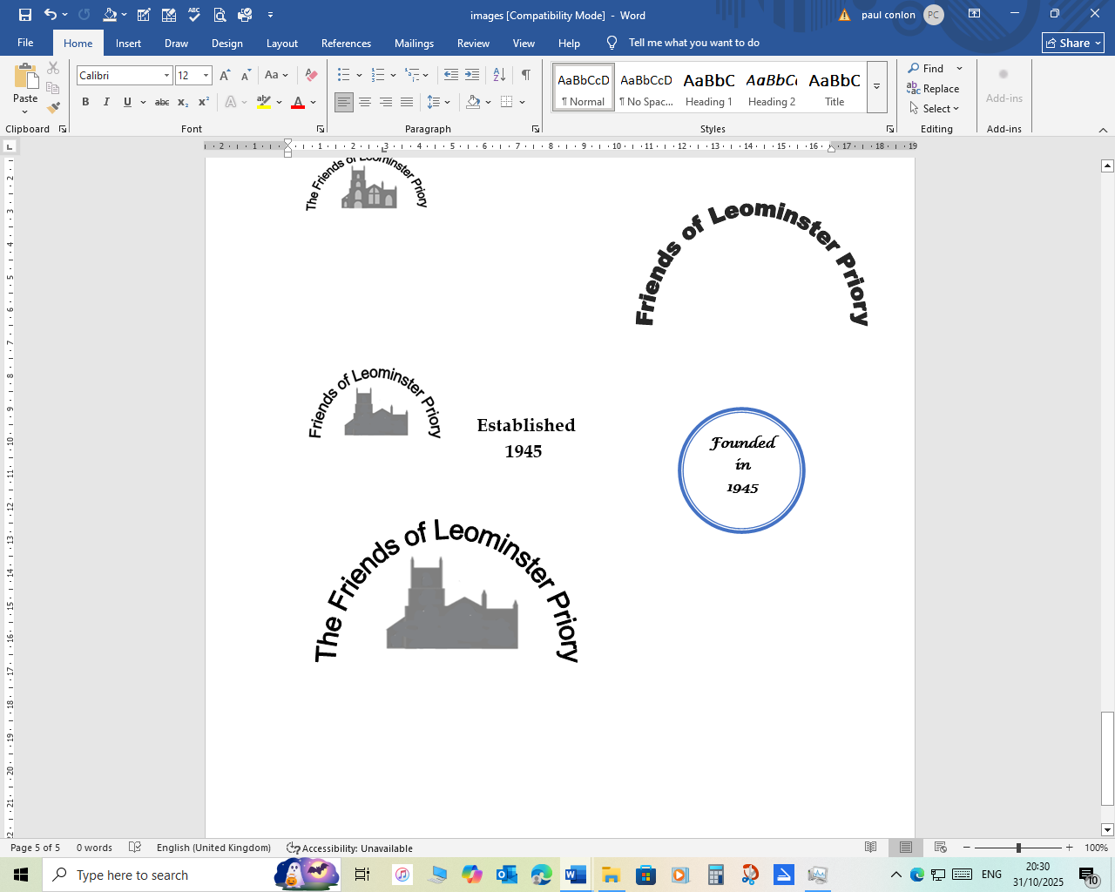
New Friends are welcome
You are warmly invited to join us by completing this form.
As a member, you will receive notification of our social events, an annual report, and newsletters.
Single membership:
£10 minimum per year
We are always very grateful if
you can add a little more to
your subscription.
Pay by Standing Order or cheque. There is also a Gift Aid declaration available for use if a UK taxpayer.
If you add your email address to the form, this is the simplest and most cost effective way of communicating with you.
Contact details stored according to GDPR.requirements.

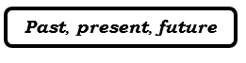
Membership form
Title: …………………………………
Name: ……………………………….
Address: …………………………….
………………………………………..
……………………………………..…
Postcode: …………………………...
Tel.no: ……………………….……....
Email: ………………………………...
To pay by STANDING ORDER
Please set it up through your own
bank as follows:
Barclays Bank for the account of
‘The Friends of Leominster Priory’
Sort: 20-39-64 Account: 30038172
The sum of £ …...…...……...………
on (date) ……………….……………
now and annually until further notice.
Signature: …………………………....
Date: …………………………………
Please send this completed form to:
The Treasurer,
‘The Friends of Leominster Priory’,
c/o The Forbury Chapel, Church
Street, Leominster, HR6 8NQ or email
thefriends@leominsterpriory.org.uk
If payment by CHEQUE:
Please make the cheque out to:
‘The Friends of Leominster Priory’
and send with the completed membership form to:
The Treasurer,
‘The Friends of Leominster Priory’,
c/o The Forbury Chapel, Church
Street, Leominster, HR6 8NQ
If using the GIFT AID scheme
I am a UK taxpayer and note that
I must have paid an amount of tax which at least equals the amount
of tax you will reclaim.
Signature: ……………….………………
Date: ………………………….…………
Please send completed GIFT AID
declaration and form to:
The Treasurer,
‘The Friends of Leominster Priory’,
c/o The Forbury Chapel, Church Street, Leominster, HR6 8NQ
or email it to thefriends@leominsterpriory.org.uk
Thank you

